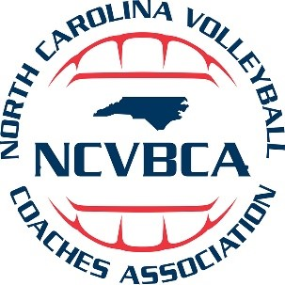
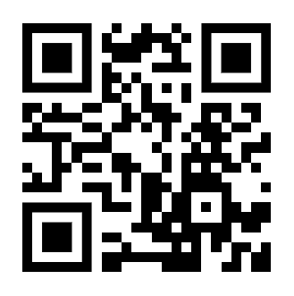
2022-23 NCVBCA Awards
Scan the QR Code to view the 2022-23 NCVBCA Awards listed, and the 2022-23 NCISAA All-State Teams.
All-Region Teams
1A All-State Team
2A All-State Team
3A All-State Team
4A All-State Team
Player of the Year
Coach of the Year
